Grettel Alvarez  
CIM540-640-2R  
Intro to Creative Coding  
Professor Zevensuy Rodriguez

Homework #1: Impossible App

**Name of App:** Plushii



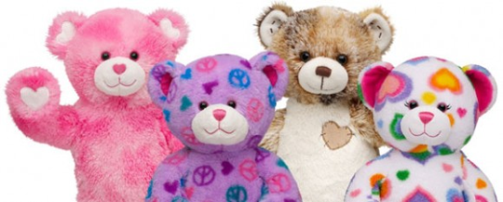

**Concept:** ‘Plushii’ is an device that allows users to bring a stuffed toy to life. It also allows a user to customize different aesthetic features such as changing the color of the toy, changing the size and giving the toy a name that it will respond to audially.

**Step 1:**

Press the power button on the Plushii device’s touch screen. Once turned on, the gates of the box will open allowing you to insert a toy inside of it.

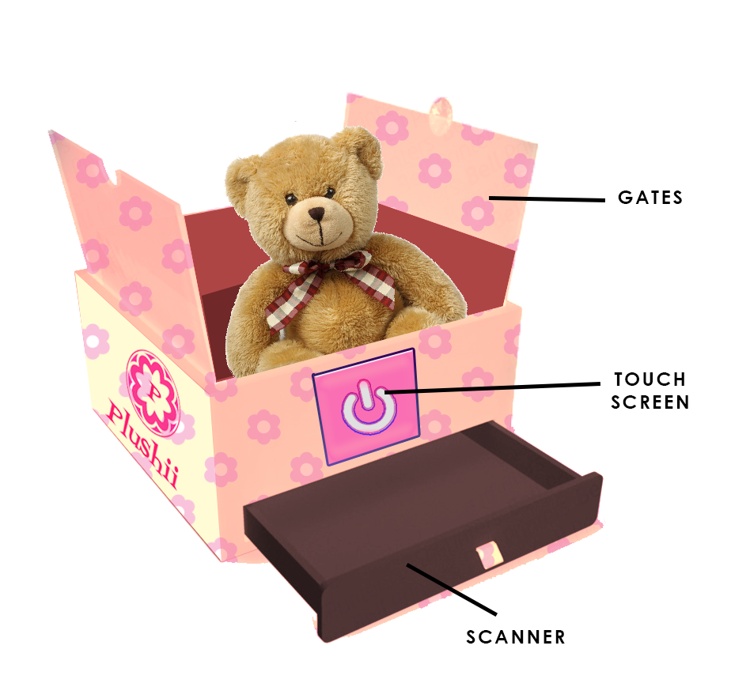

**Step 2:**

Insert your stuffed toy of choice. Once inserted, Plushii will automatically close the gates after it senses an toy has been put inside. It will scan a 3D model of the toy placed inside and will prompt users to “Continue” or “Start Over” on the touch screen.

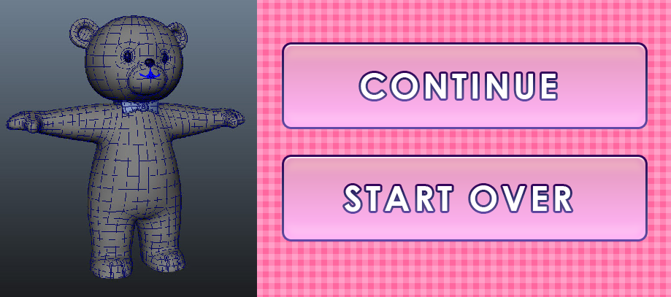

**Step 3:**

After a user chooses to continue, they will be prompted to name the toy. This is the audio keyword that the toy will respond the most to. Much like a pet.

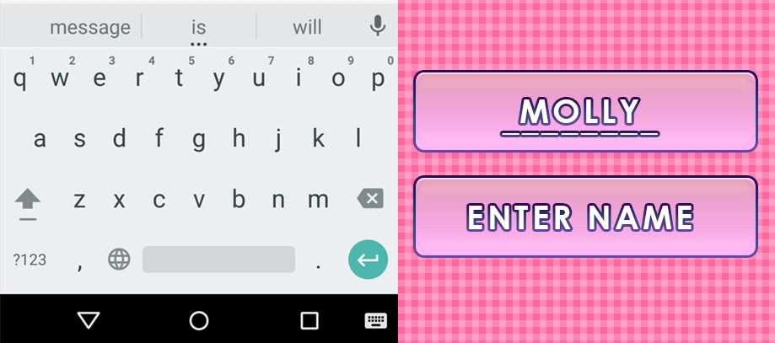

**Step 4:**

After entering a name, the 3D model of the animated toy will appear. Users can see a preview of how their toy will look like when it comes to life. 3 buttons will appear, prompting the user to options to change the color, size, or if they are pleased with the toy’s natural metrics, to ‘Bring to Life’. A red arrow to go back a previous step is also visible.

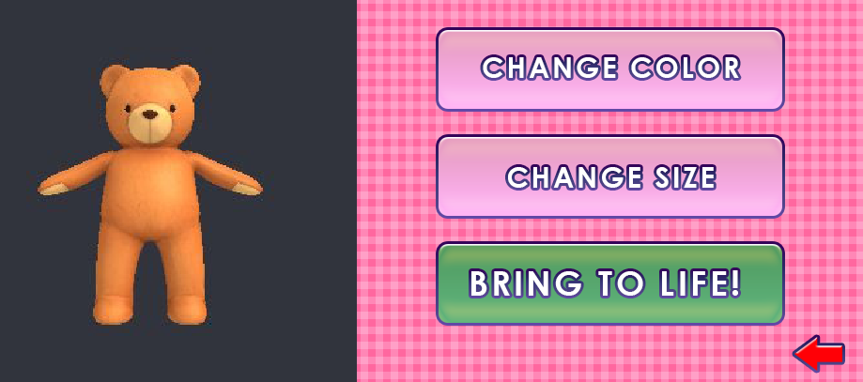

**Step 5:**

If a user selects to change the color of the toy, several pre-automated color palettes will appear. The user can select a color palette, or have the option of scanning a specific color. A user can grab a tangible object, such as handkerchief, and place it on the ‘Plushii’ scanner. Plushii will replicate the exact color, pattern onto the toy. After this process is complete and the user is happy with their result, they will return to the selection screen allowing them to proceed to finish, change the size or start over.

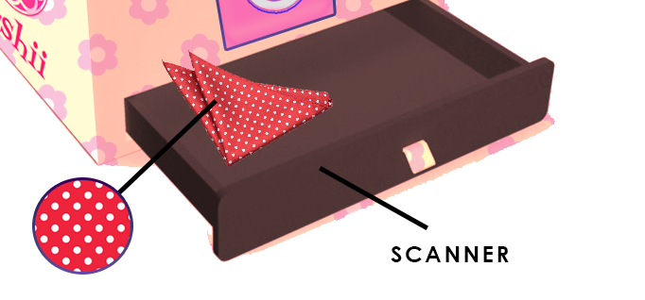

**Step 6:**

If a user selects to change the size of the toy, a slider will appear and allow the user to customize how large they would like their toy to be re-sized to. After this process is complete and the user is happy with their result, they will return to the selection screen allowing them to proceed to finish, change any other variables like the color, name or start over.

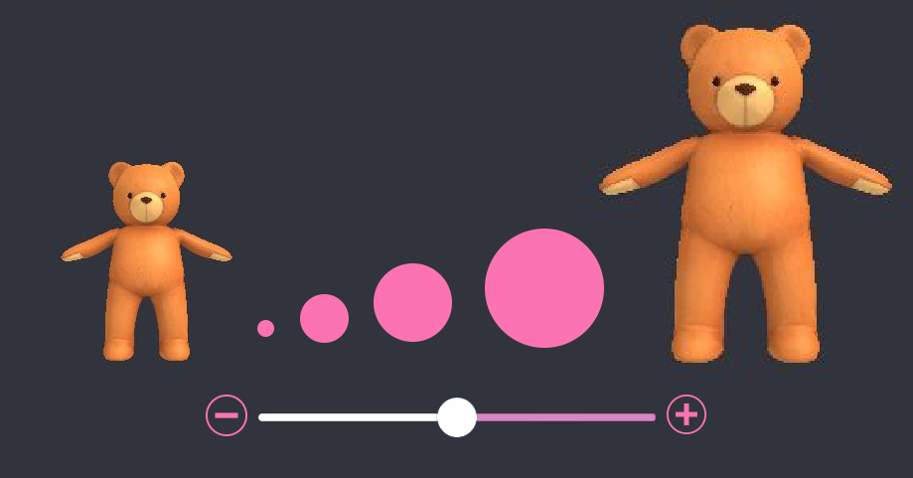

**Step 7:**

After a user is happy with all of their choices, they can press the “Bring To Life” button. The ‘Plushii’ box cover will close and a whimsical song will play as LED lights shine from inside the box. The magic is happening! After about 60 seconds, the box will open and your stuffed toy will most likely climb out on their own to greet you. Meet your new best friend!

